Software Testing

Manual testing

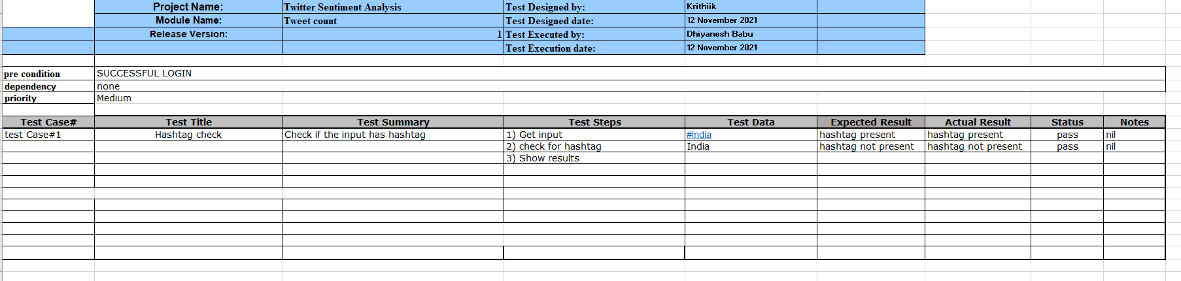

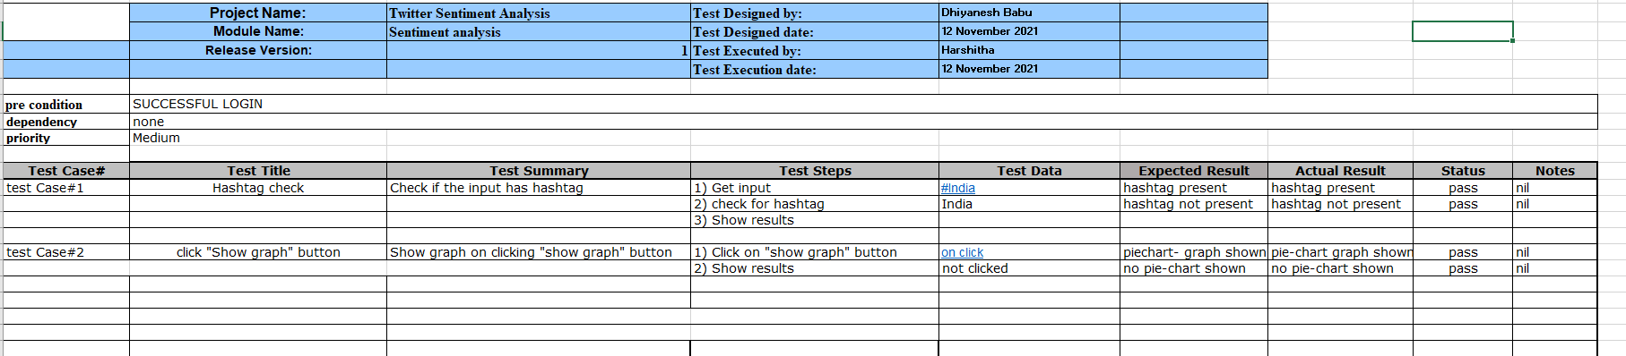

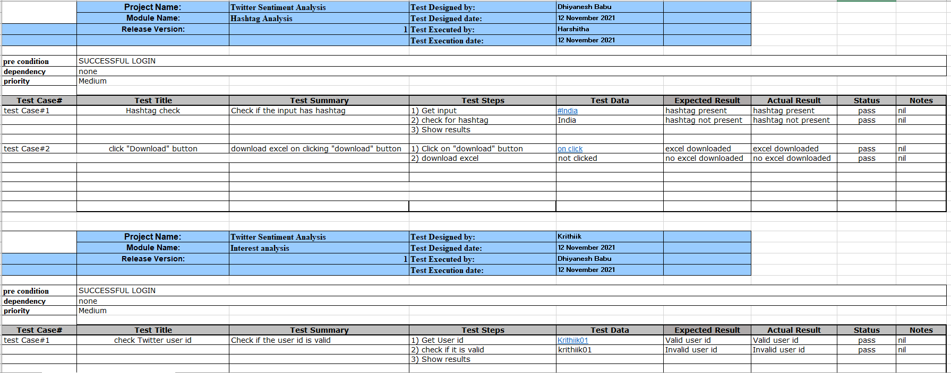

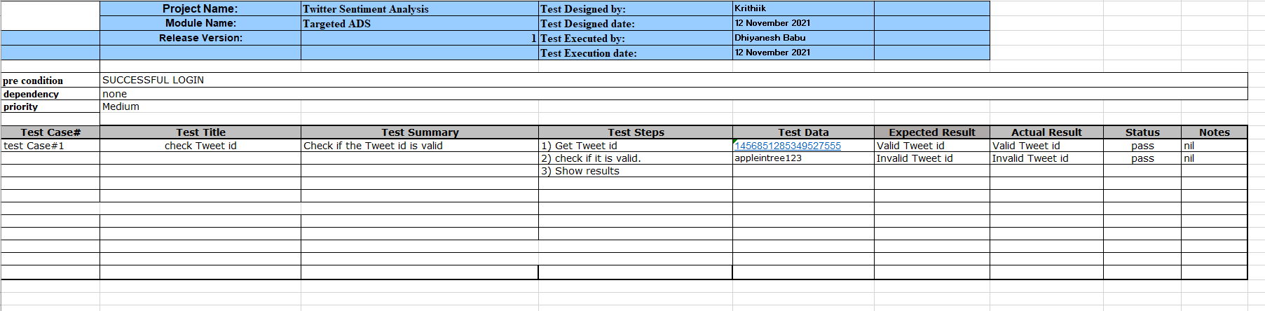

Automated Testing

http://localhost:3000/login

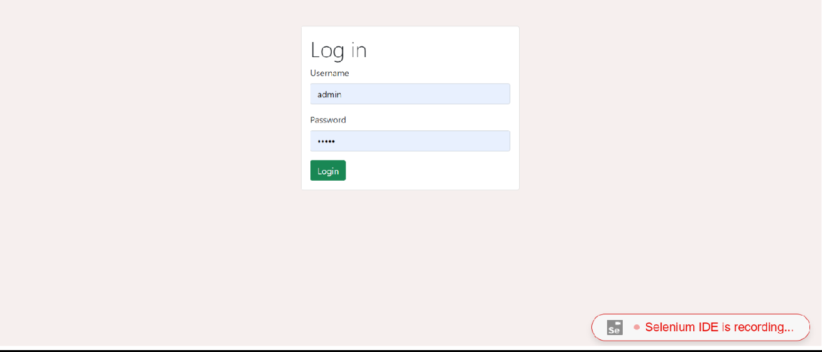

Test in Selenium

